Tema 5

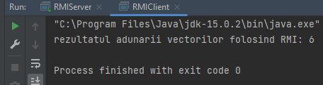

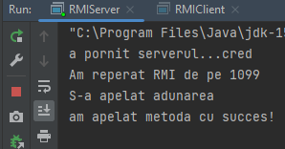

Am reusit sa fac un RMI care trimite rezultatul adunarii elementelor dintr-un vector.

INTERFATA

package org.example;  
  
import java.rmi.Remote;  
import java.rmi.RemoteException;  
  
public interface Adunare extends Remote {  
 int addNumbers(int a[]) throws RemoteException;  
  
}

CLIENT

package org.example;  
  
import java.rmi.Naming;  
  
public class RMIClient {  
 static int *rez* = 0;  
 static Adunare *adunare* = null;  
  
 public static void main(String args[]) {  
  
 try {  
 int a[] = {1, 2, 3};  
 *adunare* = (Adunare) Naming.*lookup*("//" + "localhost" + "/add");  
 *rez* = *adunare*.addNumbers(a);  
 System.*out*.println("rezultatul adunarii vectorilor folosind RMI: " + *rez*);  
 } catch (Exception e) {  
 System.*out*.println("eroarea zice: " + e.getMessage());  
 }  
 }  
  
}

SERVER

package org.example;  
  
import java.rmi.Naming;  
import java.rmi.RemoteException;  
import java.rmi.registry.LocateRegistry;  
import java.rmi.server.UnicastRemoteObject;  
  
public class RMIServer extends UnicastRemoteObject implements Adunare {  
  
  
 protected RMIServer() throws RemoteException {  
 super(0);  
  
 }  
  
 public int addNumbers(int[] a) {  
 System.*out*.println("am apelat metoda cu succes!");  
 int rez = 0;  
 for (int i = 0; i < a.length; i++) {  
 rez += a[i];  
 }  
 return rez;  
 }  
  
 public static void main(String args[]) throws Exception {  
 System.*setProperty*("java.rmi.server.hostname", "localhost");  
 System.*out*.println("a pornit serverul...cred");  
 try {  
 int port = 1099;  
 LocateRegistry.*createRegistry*(port);  
 System.*out*.println("Am reperat RMI de pe " + port);  
 } catch (Exception e) {  
 System.*out*.println("eroarea de la sserver: " + e.getMessage());  
 }  
  
 RMIServer rmiServer = new RMIServer();  
 Naming.*rebind*("add", rmiServer);  
 System.*out*.println("S-a apelat adunarea");  
 }  
  
}